**Julian Overnell’s Geological Observations from our Skye Trip, April 2014.**

**1)**

DSCF1764.jpg.  27 Apr 20014.  Looking S across the Allt Duisdale, Sleat peninsular, Skye. NG 68202,12760.  Just under the burn is the (presumed) Moine Thrust with Torridonian sandstone below and Lewisian orthogneiss above.  The Lewisian is now phylonite/mylonite sheets, above left where the rock-fall had occurred, but under these is a contorted structure (see just above the water underneath the sapling).  The presumed thrust displacement was from left to right across the picture.  The mode of formation of the contorted structure immediately above the thrust was the subject of considerable discussion.

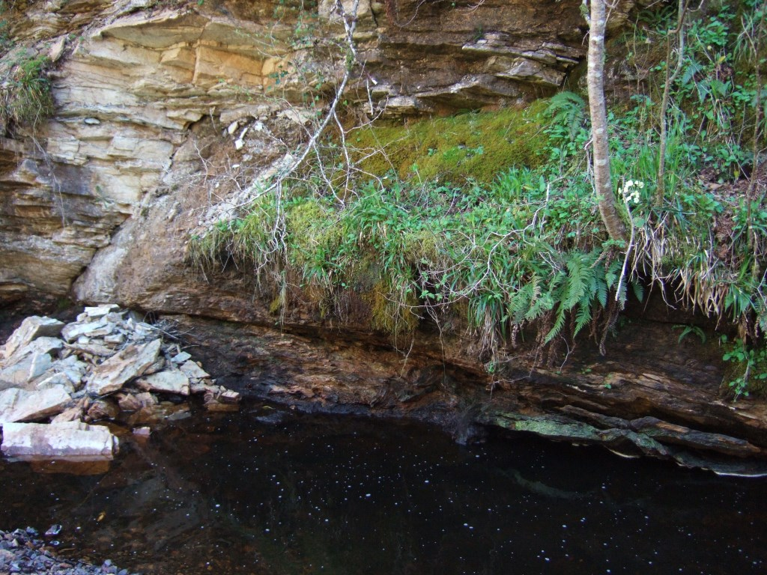

**2)**

DSCF1766.jpg.  28 Apr 20014.  Beach below cemetery, Breakish, Skye.  NG 68071,24053.  Thin ?Tertiary ?dolerite sill in Broadford Beds (Jurassic).  The intrusion shows rough polygonal jointing normal to the plane of the sill, but also a well-developed fracture parallel to the plane of the sill.  Note the unusual parallel striations on the topmost exposed part of the sill and also the same striations on the top of the fracture plane a few cms deeper.  The mode of formation of these striations is not obvious.  Perhaps they are related to magma flow in the sill parallel to these lines.

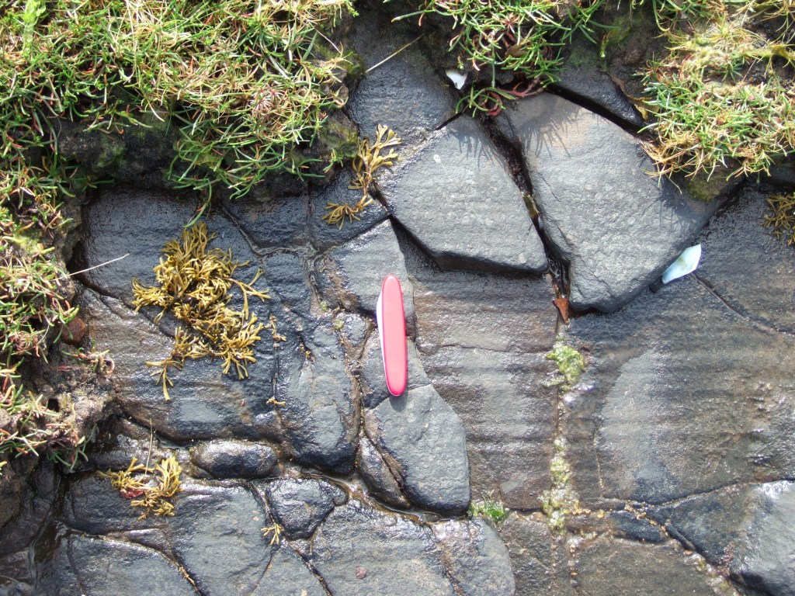

**3)**

IMG_0258.jpg  28 Apr 20014.  Beach below cemetery, Breakish, Skye.  NG 67988,24331.  Broadford Beds (Jurassic).  Unknown structure in stratum.  Sample loose, in context.  The diameter of the rim of the “crater” 5.5cm.  SG of sample 2.77.  There were many other similar structures *in situ*, although most were of a smaller diameter.  There was no evidence on the underside of the sample of a continuation below (such as might be evident with a worm burrow).  The brown matrix shows much fizzing with acid, but the black structure does not fizz.  Can you identify this ?

